**A MINI PROJECT REPORT**

**ON**

**GAS LEVEL DETECTION AND AUTOMATIC BOOKING USING IOT**

*A Mini Project submitted in the partial fulfillment of the requirements for the award of the degree of*

**BACHELOR OF TECHNOLOGY**

**in**

**ELECTRONICS AND COMMUNICATION ENGINEERING**



**By**

**K. ANJANA (20281A0452)**

**A. SHIVA KUMAR (21285A0412)**

**A. SUSMITHA (20281A0435)**

**S. SAITEJA (20281A0444)**

**S. RATHAN (20281A0433)**

**Under the guidance of**

**Mr. U. RAJA IAH**

**Assistant Professor**

**KAMALA INSTITUTE OF TECHNOLOGY AND SCIENCE, SINGAPUR**

**HUZURABAD, KARIMNAGAR, TELANGANA, INDIA-505468**

**(**Approved by AICTE, New Delhi, and affiliated to JNTU, Hyderabad, T. S**)**

2023-2024

**A MINI PROJECT REPORT**

**ON**

**GAS LEVEL DETECTION AND AUTOMATIC BOOKING USING IOT**

*A Mini Project submitted in the partial fulfillment of the requirements for the award of the degree of*

**BACHELOR OF TECHNOLOGY**

**in**

**ELECTRONICS AND COMMUNICATION ENGINEERING**



**By**

**K. ANJANA (20281A0452)**

**A. SHIVAKUMAR (21285A0412)**

**A. SUSMITHA (20281A0435)**

**S. SAITEJA (20281A0444)**

**S. RATHAN (20281A0433)**

**Under the guidance of**

**Mr. U. RAJAIAH**

**Associate Professor**

**KAMALA INSTITUTE OF TECHNOLOGY AND SCIENCE, SINGAPUR**

**HUZURABAD, KARIMNAGAR, TELANGANA, INDIA-505468**

**(**Approved by AICTE, New Delhi, and affiliated to JNTU, Hyderabad, T. S**)**

2023-2024

**KAMALA INSTITUTE OF TECHNOLOGY AND SCIENCE, SINGAPUR**

**HUZURABAD, KARIMNAGAR, TELANGANA, INDIA-505468**

**(**Approved by AICTE, New Delhi and affiliated to JNTU, Hyderabad, T. S**)**



**DEPARTMENT OF**

**ELECTRONICS AND COMMUNICATION ENGINEERING**

**CERTIFICATE**

This is to certify that this is a minor project work entitled **GAS LEVEL DETECTION AND AUTOMATOC BOOKING USING IOT** is a work carried out by **K.ANJANA (20281A0452),A.SHIVAKUMAR (21285A0412),A.SUSMITHA (20281A0435),S. SAITEJA (20281A0444), S. RATHAN (20281A0433)** submitted in partial fulfillment of the requirements for the award of the degree in Bachelor of Technology in Electronics And Communication Engineering by Jawaharlal Nehru Technological University, Hyderabad during the academic year 2022-2023.

**Project Guide Head of the Department Principal**

**Mr. U. RAJAIAH Dr. B. RAMESH Dr. K. SHANKER**

**Assistant Professor Professor Professor**

**ACKNOWLEDGMENT**

We express our profound gratitude and deep regard to all the people who extended their support with timely suggestions and indispensable help, which made this project feasible.

We sincerely thank **Mr. U. RAJAIAH,** Assistant professor for assisting and monitoring as project guide.

We take this opportunity to express our deep sense of gratitude and respect to our project coordinator **Mr. V. VIKRAM,** Assistant professor with his constant encouragement it would not have been possible to complete this work. We express unfeigned gratitude towards our project coordinator for his valuable guidance in the completion of our project.

Our special thanks to **Dr. B. RAMESH,** Professor, head of the Department of Electronics and Communication Engineering, for their suggestions and wholehearted support.

We are extremely grateful to **Dr. K. SHANKER,** principal, Kamala Institute of Technology and Science, Singapur, for providing the requisite facilities during the project work.

Finally, we would like to extend our sincere thanks to all teaching staff members of the ECE Department for their kind cooperation and valuable help towards the project in the form of encouragement and moral support.

**K. ANJANA (20281A0452)**

**A. SHIVAKUMAR (21285A0412)**

**A. SUSMITHA (20281A0435)**

**S. SAITEJA (20281A0444)**

**S. RATHAN (20281A0433)**

**i**

**ABSTRACT**

Gas leakages are a severe problem in residences and other areas where residential gas is utilized. The consumer has no idea of how much gas is being used and how much time left when he or she needs to book a new LPG cylinder. As a result, in this project, we offer an internet of things (IOT)-based system that analyses several characteristics of an LPG cylinder and, as a result, keeps the consumer informed via a mobile application. When the gas level is falls below the threshold, an alert message will receive to the user via the buzzer and via the mobile app, and when the LPG level is extremely low, the amount of gas in the cylinder is found using a sensor called a load cell and the rate of gas remaining in the cylinder is updated to the app that is being used by the user (below 20 percent). We prevent prebooking and late booking by automating the booking of new LPG. When a gas leak is detected,the user is notified via a mobile application and a buzzer.

ii

**LIST OF FIGURES**

**Name of the figures Page Numbers**

Figure 1.2.1: 4-Stage IOT Architecture 2

Figure 1.2.2: Application Layer 3

Figure1.2.3:Smart Environment Application Domains 4

Figure 1.2.4:Smart Environment Application Domain Services classification 4

Figure 1.3.1:IOT Connection 6

Figure 2.3.1:Block Diagram 13

Figure 2.4.2 functionality of the system 14

Figure 3.2.1: Arduino Architecture 16

Figure 3.3.1: ADC conversion 17

Figure 4.1.1:ESP8266 WI-FI module 22

Figure 4.1.2: Block Diagram 23

Figure 4.1.3 NodeMCU ESP8266 pin description 24

Figure 4.2.1 BUZZER Pin Configuration 27

Figure 4.3.1 MQ2 Gas Sensor 31

Figure 4.4.1 wireless-sensor-module 33

Figure 5.1.1 Downloading Software 36

Figure 5.1.2 Launching Arduino IDE 36

Figure 5.1.3 Creating process 37

Figure 5.1.4 Selecting Arduino board 38

Figure 5.1.5 Serial port 38

Figure 5.1.6 Symbol in Ardunio Toolbar 39

**LIST OF CONTENTS**

ACKNOWLEDGMENT........................................................................................................................4i

ABSTRACT ..........................................................................................................................................5

LIST OF FIGURES ...............................................................................................................................6v CHAPTER-1 ..………………………………………………………………………………………...1

INTRODUCTION…………………………………………………………………………………….1

1.1 Introduction to IOT………………………………………………………………………….. ..1

1.2 IOT ARCHITECTURE………………………………………………………………………...1

1.3 IOT − KEY FEATURES………………………………………………………………………..4

CHAPTER-2…………………………………………………………………………………………..9

2.1 INTRODUCTION………………………………………………………………………………9

2.2 EXISTING SYSTEM……………………………………………………………………………9

2.3 LITERATURE SURVEY………………………………………………………………………10

2.4 PROPOSED METHOD………………………………………………………………………..10

CHAPTER-3…………………………………………………………………………………………13

3.1 INTRODUCTION………………………………………………………………………………13

3.2 ARDUINO ARCHITECTURE ……………………………………………………………..…..14

3.3 BASIC TERMINOLOGIES IN ARDUINO…………………………………………………….15

3.4 LANGUAGE REFERENCES…………………………………………………………………..15

3.5 APPLICATIONS OF ARDUINO……………………………………………………………….16

CHAPTER-4………………………………………………………………………………………….18

4.1 Node MCU-ESP8266……………………………………………………………………………18

4.2 Buzzer Working & Its Applications……………………………………………………………..22

4.3 MQ2 Gas Sensor Working and Its Applications………………………………………………...26

4.4 Weight Sensor Working and Its Specifications………………………………………………….28

4.5 HX711 Specifications……………………………………………………………………………30

CHAPTER-5…………………………………………………………………………………………..31

5.1 CREATING PROJECT IN ARDUINO 1.7.11 VERSION5……………………………………..31

5.2 Software code……………………………………………………………………………………34

CHAPTER-5…………………………………………………………………………………………..38

6.1 ADVANTAGES………………………………………………………………………………….38

s

**CHAPTER-1**

**IOT TECHNOLOGY**

**1.1 INTRODUCTION TO IOT:**

Internet of Things (IOT) is the networking of physical objects that contain electronics embedded within their architecture in order to communicate and sense interactions among each other or with respect to the external environment. In the upcoming years, IOT-based technology will offer advanced levels of services and practically change the way people lead their daily lives. Advancements in medicine, power, gene therapies, agriculture, smart cities, and smart homes are just a very few of the categorical examples where IOT is strongly established.

Over 9 billion ‘Things’ (physical objects) are currently connected to the Internet, as of now. In the near future, this number is expected to rise to a whopping 20 billion. In the consumer market, IOT technology is most synonymous with products pertaining to the concept of the "smart home", including devices and appliances (such as lighting fixtures, thermostats, home security systems and cameras, and other home appliances) that support one or more common ecosystems, and can be controlled via devices associated with that ecosystem, such as smart phones and smart speakers. The IOT can also be used in healthcare systems.

The Internet of Things (IOT) is a system of interrelated computing devices, mechanical and digital machines, objects, animals or people that are provided with unique identifiers and the ability to transfer data over a network without requiring human-to-human or human-to-computer interaction.

In the consumer market, IOT technology is most synonymous with products pertaining to the concept of the "smart home", covering devices and appliances (such as lighting fixtures, thermostats, home security systems and cameras, and other home appliances) that support one or more common ecosystems, and can be controlled via devices associated with that ecosystem, such as smart phones and smart speakers.

**1.2 IOT ARCHITECTURE:**

The Internet of things (IoT) describes physical objects (or groups of such objects) that are embedded with sensors, processing ability, software, and other technologies that connect and exchange data with other devices and systems over the Internet or other communications networks. There are a number of concerns about the risks in the growth of IOT technologies and products, especially in the areas of privacy and security, and consequently.

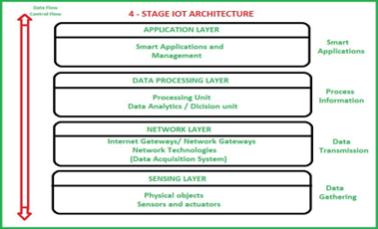

**Figure 1.2.1: 4-Stage IOT Architecture**

**Sensing Layer :**

Sensors, actuators, devices are present in this Sensing layer. These Sensors or Actuators accepts data(physical/environmental parameters), processes data and emits data over network.

**Network Layer :**

Internet/Network gateways, Data Acquisition System (DAS) are present in this layer. DAS performs data aggregation and conversion function (Collecting data and aggregating data then converting analog data of sensors to digital data etc). Advanced gateways which mainly opens up connection between Sensor networks and Internet also performs many basic gateway functionalities like malware protection, and filtering also sometimes decision making based on inputted data and data management services, etc.

**Data processing Layer :**

This is processing unit of IOT ecosystem, here data is analyzed and pre-processed before sending it to data center This is processing unit of IOT ecosystem. Here data is analyzed and pre-processed before sending it to data center from where data is accessed by software applications often termed as business applications where data is monitored and managed and further actions are also prepared. So here Edge IT or edge analytics comes into picture.

**Application Layer :**

This is last layer of 4 stages of IOT architecture. Data centers or cloud is management stage of data where data is managed and is used by end-user applications like agriculture, health care, aerospace, farming, defense, etc. Application layer forms the topmost layer of IOT architecture which is responsible for effective utilization of the data collected. Various IOT applications include Home Automation, E-health, E-Government, etc.

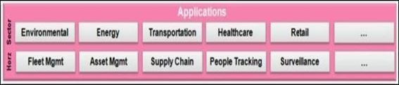

**Figure 1.2.2: Application Layer**

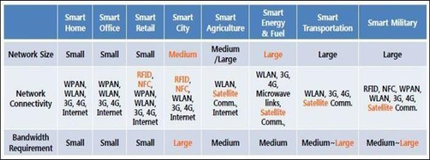

**Figure 1.2.3:Smart Environment Application Domains**

where, WLAN stands for Wireless Local Area Network which includes Wi-Fi, WAVE, IEEE 802.11 a/b/g/p/n/ac/ad, and so on and WPAN stands for Wireless Personal Area Network which includes Bluetooth, ZigBee, 6LoWPAN, IEEE 802.15.4, UWB, and so on.

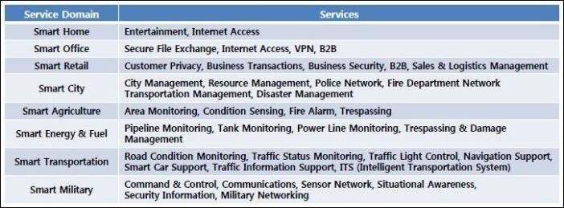

**Figure 1.2.4:Smart Environment Application Domain Services classification**

**1.3 IOT − KEY FEATURES:**

The most important features of IoT include artificial intelligence, connectivity, sensors, active engagement, and small device use. A brief review of these features is given below :

AI − IoT essentially makes virtually anything “smart”, meaning it enhances every aspect of life with the power of data collection, artificial intelligence algorithms, and networks. This can mean something as simple as enhancing your refrigerator and cabinets to detect when milk and your favorite cereal run low, and to then place an order with your preferred grocer.

**Connectivity** − New enabling technologies for networking, and specifically IoT networking, mean networks are no longer exclusively tied to major providers. Networks can exist on a much smaller and cheaper scale while still being practical. IoT creates these small networks between its system devices.

**Sensors** − IoT loses its distinction without sensors. They act as defining instruments which transform IoT from a standard passive network of devices into an active system capable of real- world integration.

**Active Engagement** − Much of today's interaction with connected technology happens through passive engagement. IoT introduces a new paradigm for active content, product, or service engagement.

**Small Devices −**Devices, as predicted, have become smaller, cheaper, and more powerful over time. IoT exploits purpose-built small devices to deliver its precision, scalability, and versatility.

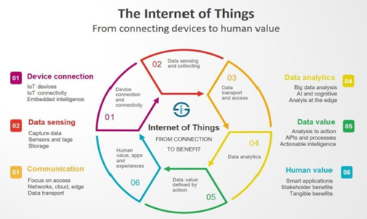

**Figure 1.3.1:IOT Connection**

**ADVANTAGES :**

**Technology Optimization −** The same technologies and data which improve the customer experience also improve device use, and aid in more potent improvements to technology. IoT unlocks a world of critical functional and field data.

**Reduced Waste −** IoT makes areas of improvement clear. Current analytics give us superficial insight, but IoT provides real-world information leading to more effective management of resources.

**Enhanced Data Collection −** Modern data collection suffers from its limitations and its design for passive use. IoT breaks it out of those spaces, and places it exactly where humans really want to go to analyze our world. It allows an accurate picture of everything.

**IOT − DISADVANTAGES:**

**Privacy −** The sophistication of IoT provides substantial personal data in extreme detail without the user's active participation.

**Complexity −** Some find IoT systems complicated in terms of design, deployment, and maintenance given their use of multiple technologies and a large set of new enabling technologies.

**Flexibility −** Many are concerned about the flexibility of an IoT system to integrate easily another. They worry about finding themselves with several conflicting or locked systems.

**HOW IOT WORKS:**

First, it acquires information with respect to basic resources (names, addresses and so on) and related attributes of objects by means of automatic identification and perception technologies such as RFID, wireless sensor and satellite positioning, in other words, the sensors, RFID tags, and all other uniquely identifiable objects or "things" acquire real-time information (data) with the virtue of a central hub like smart phones.

Second, by virtue of many kinds of communications technologies, it integrates object- related information into the information network and realizes the intelligent indexing and integration of the information related to masses of objects by resorting to fundamental resource services (similar to the resolution, addressing and discovery of the internet).

Finally, utilizing intelligent computing technologies such as cloud computing, fuzzy recognition, data mining, and semantic analysis, it analyzes and processes the information related to masses of objects so as to eventually realize intelligent decision and control in the physical world.

**SECURITY:**

Security is the biggest concern in adopting Internet of things technology, with concerns that rapid development is happening without appropriate consideration of the profound security challenges involved and the regulatory changes that might be necessary. Most of the technical security concerns are similar to those of conventional servers, workstations and smart phones, and include weak authentication, forgetting to change default credentials, un encrypted messages sent between devices, SQL injections and poor handling of security updates.

Internet of things devices also have access to new areas of data, and can often control physical devices. So that even by 2014 it was possible to say that many Internet-connected appliances could already "spy on people in their own homes" including televisions, kitchen appliances, cameras, and thermostats. Computer-controlled devices in automobiles such as brakes, engine, locks, hood and trunk releases, horn, heat, and dashboard have been shown tobe vulnerable to attackers who have access to the on-board network. In some cases, vehicle computer systems are Internet-connected, allowing them to be exploited remotely. By 2008 security researchers had shown the ability to remotely control pacemakers without authority. Later hackers demonstrated remote control of insulin pumps and implantable cardioverter defibrillators.

**SAFETY:**

IoT systems are typically controlled by event-driven smart apps that take as input either sensed data, user inputs, or other external triggers (from the Internet) and command one or more actuators towards providing different forms of automation. Examples of sensors include smoke detectors, motion sensors, and contact sensors. Examples of actuators include smart locks, smart power outlets, and door controls. Popular control platforms on which third-party developers can build smart apps that interact wirelessly with these sensors and actuators include Samsung's Smart Things, pple's Home Kit, and Amazon's Alexa, among others.

Detecting flaws that lead to such states, requires a holistic view of installed apps, component devices, their configurations, and more importantly, how they interact. Recently, researchers from the University of California Riverside have proposed IoTSan, a novelpractical system that uses model checking as a building block to reveal "interaction-level" flaws by identifying events that can lead the system to unsafe states.

**CLOUD DATA:**

**FIRE BASE:**

Firebase evolved from Envolve, a prior startup founded by James Tamplin and Andrew Lee in 2011. Envolve provided developers an API that enables the integration of online chat functionality into their websites. After releasing the chat service, Tamplin and Lee found that it was being used to pass application data that weren't chat messages. Developers were using Envolve to sync application data such as game state in real time across their users. Tamplin and Lee decided to separate the chat system and the real-time architecture that powered it. They founded Firebase as a separate company in September 2011and it launched to the public in April 2012.

Firebase's first product was the Firebase Real-time Database, an API that synchronizes application data across iOS, Android, and Web devices, and stores it on Firebase's cloud. The product assists software developers in building real-time, collaborative applications.In May 2012, one month Firebase's first product was the Firebase Real-time Database, an API that synchronizes application data across iOS, Android, and Web devices, and stores it on Firebase's cloud. The product assists software developers in building real-time, collaborative applications.In May 2012, one month after the beta launch, Firebase raised $1.1M in seed funding from venture capitalists Flybridge Capital Partners, Greylock Partners, Founder Collective, and New Enterprise Associates.

In May 2016, at Google I/O, the company's annual developer conference, Firebase expanded its services to become a unified platform for mobile developers. Firebase now integrates with various other Google services, including Google Cloud Platform, AdMob, and Google Ads to offer broader products and scale for developers. Google Cloud Messaging, the Google service to send push notifications to Android devices, was superseded by a Firebase product, Firebase Cloud Messaging, which added the functionality to deliver push notification to iOS and Web devices. In January 2017, Google acquired Fabric and Crashlytics from Twitter to add those services to Firebase. In October 2017, Firebase launched Cloud Firestore, a real-time document database as the successor product to the original Firebase Real-time Database.

**Firebase Real-time Database:**

Firebase provides a real-time database and back end as a service. The service provides application developers an API that allows application data to be synchronized across clients and stored on Firebase's cloud. The company provides client libraries that enable integration with Android, iOS, JavaScript, Java, Objective-C, Swift and Node.js applications. The database is also accessible through a REST API and bindings for several JavaScript frameworks such as AngularJS, React, Ember.js and Backbone.js.

**Firebase Cloud Firestore:**

On January 31st 2019, Cloud Firestore was officially brought out of beta, making it an official product of the Firebase line-up. It is the successor to Firebase's original data basing system, Real-time Database, and allows for nested documents and fields rather than the tree-view provided in the Real-time Database.

**Firebase Storage:**

Firebase Storage provides secure file uploads and downloads for Firebase apps, regardless of network quality. The developer can use it to store images, audio, video, or other user-generated content. Firebase Storage is backed by Google Cloud Storage.

**Firebase Hosting:**

Firebase Hosting is a static and dynamic web hosting service that launched on May 13, 2014. It supports hosting static files such as CSS, HTML, JavaScript and other files, as well as support through Cloud Functions. The service delivers files over a content delivery network (CDN) through HTTP Secure (HTTPS) and Secure Sockets Layer encryption (SSL). Firebase partners with fastly, a CDN, to provide the CDN backing Firebase Hosting. The company states that Firebase Hosting grew out of customer requests; developers were using Firebase for its real-time database but needed a place to host their content.

**APPLICATIONS OF IoT:**

1. Smart Homes.

2. Smart City.

3. Self-driven Cars.

4. IoT Retail Shops.

5. Farming.

6. Industrial Internet.

**CHAPTER-2**

**OVERVIEW OF THE PROJECT**

* 1. **INTRODUCTION:**

In this chapter introduction of the IOT BASED LPG GAS BOOKING SYSTEM are discussed. It gives overall view of the project design and the related literature and the environment to be considered. Chapter wise organization of the thesis and the appendices is given at the end of this chapter.

Now a days Technology has advanced such that any work can be done easily and in less time. Manual gas booking is a time consuming process in which the amount of gas in the cylinder is not known exactly and is known only after the gas in the cylinder is empty. Then the cylinder is booked and it may take a week to get the new cylinder. If the amount of gas is known, it is possible to book the cylinder before it is empty and can get the new cylinder. Using IOT this job can be done easily. So, this IOT project is designed for automatic gas booking. Many of the domestic accidents occur due to the unawareness of the leakage of gas. LPG gas is a mixture of propane, butane and propylene and it is highly flammable. The permitted level for butane is 600 ppm above which it is not safe [6]. Whenever the gas leaks, it will mix with the air and form a combustible mixture and explodes when it comes in contact with any spark. As safety plays an important role, this project is also designed to avoid the accidents that occur due to the leakage of LPG Gas. Amount of gas is known by measuring the weight of gas cylinder. To measure the weight, Load cell a weight sensor is used. It continuously measures the weight of the cylinder and displays on an IOT platform, APP. A threshold level is set before the gas is completely consumed. And if the weight of the gas cylinder is less than the threshold, it is indicated using an indicator in APP and an email is also sent to the gas agency and the cylinder is booked automatically.MQ2 gas sensor is used to sense the gas leakage.MQ2 sensor module can detect LPG, smoke, alcohol, hydrogen gas etc. In this project it continuously measures the concentration of gases and the concentration is displayed on APP. whenever there is LPG gas leakage, concentration increases and the increase is displayed on APP. And if the increased concentration is more than a specified level it is dangerous, so an indicator is used to indicate this and an alert message is sent to the user.

**2.2 EXISTING SYSTEM:**

LPG gas booking is manually booking customer when the gas cylinder was empty.

**2.3 LITERATURE SURVEY:**

LPG gas was first introduced in 1910 by Dr. Walter Snelling. It is a mixture of commercial propane and butane. It is highly flammable and many of the accidents occur due to the leakage of LPG. Thus there is a need to detect and prevent the gas leakage. Gas detectors have been used for a long time and have wide range of applications in homes, paper pulp mills, refineries, industrial plants, refineries, aircraft etc. . The system proposed by Digambar Surse1 et.al uses ARM7 microcontroller. It uses MQ6 gas sensor to measure the concentration of gas. When there is gas leakage, it alerts the user through alarm and through message and turns off the main power supply. Load cell is used to measure the weight of cylinder. When the weight of the cylinder is below a threshold level of 2Kg,it sends SMS to gas agency using GSM module to book new cylinder. The system presented by Abid Khan et.al [4] uses 89C51RD2 Microcontroller, LCD Display, LED, Buzzer and GSM Modem. All the devices are connected to the microcontroller. LCD display continuously displays level of gas inside the cylinder. When the level is below a particular threshold, MS using GSM is sent to the user and gas agency to book cylinder.MQ6 gas sensor is used to detect the leakage of gas. When there is gas leakage, it activates buzzer and a message is sent to user. The proposed system uses MQ2 gas sensor to sense the gas leakage and Load cell to measure the weight of cylinder. It uses NodeMcu micro controller and ubidots, IOT platform to send message and email to the user and gas agency. The following are the advantages: This system avoids the usage of GSM or Bluetooth modules to send messages. It allows to book the cylinder without the intervention of user and provides security from the gas leakage by sending message to the gas agency and the user using NodeMcu and ubidots. User gets to know about the gas leakage even without the internet connection in his mobile, only the wifi should be provided to the Nodemcu to which all sensors are connected. This system is easy to implement and use.

**2.4 PROPOSED METHOD:**

In automatic gas cylinder booking we continuously measure the amount of gas present in the cylinder using load cell which is interfaced with the Node MCU and send the date to cloud and the user held application. When gas level goes below the set level then message will be send to the gas agency and notification about same is send to the user. So, user get cylinder within time. In gas leakage detection process, any gas leakage is checked by gas sensor( MQ_2) which is interfaced with Node MCU. When leakage is detected motor will be immediately turn

off the gas regulator-switch at same time it informs the user aboutthe gas leakage by sending SMS,turning on the buzzer.

**Advantages of Gadget over existing Technology:**

* Portable Can be easily carried any where
* Comfortable and Easy to Use
* Reduced Cost
* Wi-Fi Enabled
* Easy monitoring

**BLOCK DIAGRAM:**

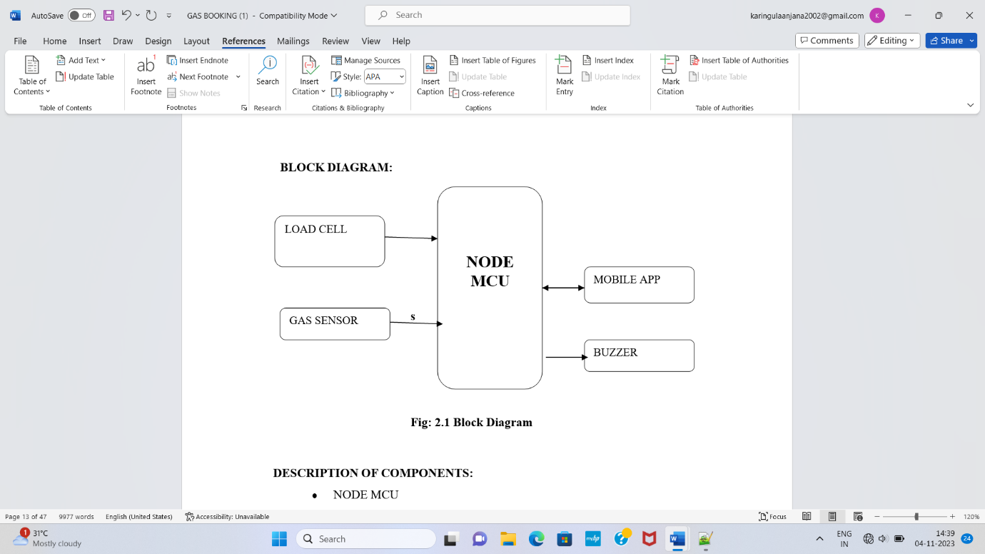

**2.4.1 Block Diagram**

**Figure 2.3.1:Block Diagram**

**DESCRIPTION OF COMPONENTS:**

* NODE MCU
* BUZZER
* LOAD CELL
* MQ2 GAS SENSOR
* MOBILE APP

**WORKING:**

Gasoline discharge detection in addition to gas quantity inside the cylinder and arrange another gas cylinder automatically. Once gas leakage is detected, all electrical appliances are automatically switched off and the buzzer will sound that notifies the gas leakage is occurred in the area. A weight sensor is the forced sensor which converts a power like tension, compression, pressure towards electrical signal. This paper uses the beam type load cell and it operates as simple cantilevers that flex slightly while subjected to force or weight. The rated load of the beam cell is 10kg. After knowing the weight of the cylinder, the message can be delivered to the user whether the cylinder is empty or normal by the use of IOT technology and auto booking is done by the user in the easiest way. The result is display in the APP. The ESP8266 WIFI module can be incorporated in this system which allows ATmega8 microcontroller to link to a WIFI network. It can work with a microcontroller like node mcu or it can be programmed to work on its own so it makes IOT as user friendly.

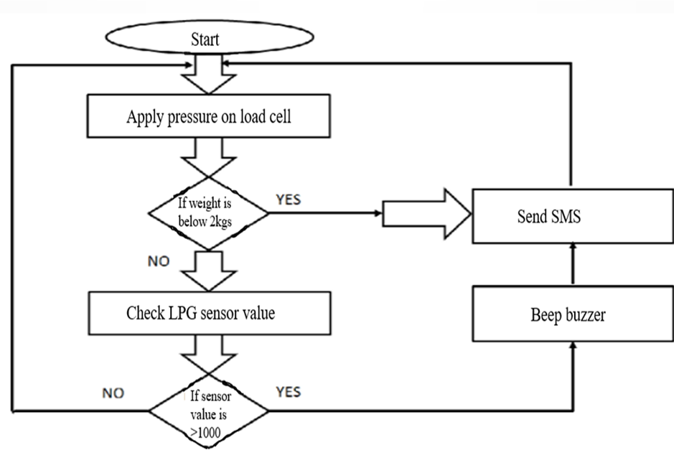

**Figure 2.4.2 functionality of the system**

**CHAPTER-3**

**ARDUINO**

**3.1 INTRODUCTION:**

Arduino is an open-source electronics platform based on easy-to-use hardware and software. Arduino boards are able to read inputs - light on a sensor, a finger on a button, or a Twitter message- and turn it into an output - activating a motor, turning on an LED, publishing something online. You can tell your board what to do by sending a set of instructions to the micro controller on the board. Over the years Arduino has been the brain of thousands of projects, from everyday objects to complex scientific instruments. A worldwide community of makers - students, hobbyists, artists, programmers, and professionals - has gathered around this open-source platform, their contributions have added up to an incredible amount of accessible knowledge that can be of great help to novices and experts alike.

Arduino has been used in thousands of different projects and applications. The Arduino software is easy-to-use for beginners, yet flexible enough for advanced users. It runs on Mac, Windows, and Linux. Teachers and students use it to build low cost scientific instruments, to prove chemistry and physics principles, or to get started with programming and robotics. Designers and architects build interactive prototypes, musicians and artists use it for installations and to experiment with new musical instruments. Makers, of course, use it to build many of the projects exhibited at the Maker Fair, for example. Arduino is a key tool to learn new things. Anyone - children, hobbyists, artists, programmers - can start tinkering just following the step by step instructions of a kit, or sharing ideas online with other members of the Arduino community.

**3.2 ARDUINO ARCHITECTURE:**

Basically, the processor of the Arduino board uses the Harvard architecture where the program code and program data have separate memory. It consists of two memories such as program memory and data memory. Wherein the data is stored in data memory and the code is stored in the flash program memory.

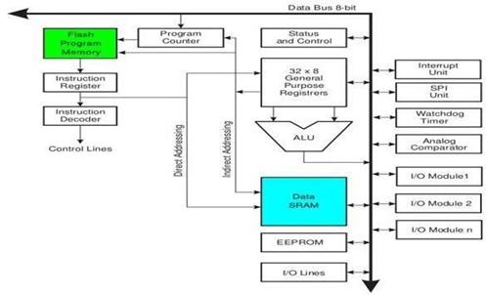

**Figure 3.2.1: Arduino Architecture**

Now, let us see the details of the various building blocks of the hardware of an Arduino. The building blocks are:

* Power
* Pins -5V, 3.3V, GND, Analog, Digital
* Reset Button.
* Main IC
* Power LED Indicator
* TX RX LED’s.
* Voltage Regulator.

**3.3 BASIC TERMINOLOGIES IN ARDUINO:**

1. **Analog to digital converter (ADC):**

The Arduino has 10 bits of Resolution when reading analog signals. 2 power 10=1024 increments

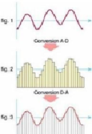

**Figure 3.3.1: ADC conversion**

1. **Pulse Width Modulation (PWM):**

The Arduino has 8-bit of resolution, when outputting a signal using PWM. The range of output voltage is from 0 to 5Volts. Average of on/of (digital signals to make an average voltage). Duty cycle in 100% of 5Volts.

2power 8=255 Increments

**3.4 LANGUAGE REFERENCES:**

The Micro controller on the board is programmed using the Arduino programming language (based on wiring) and the Arduino development environment (based on processing).

Arduino Programming Language (APL) (based on wiring)

The Arduino programming language is an implementation of Wiring, a similar physical computing platform, which is based on the Processing multimedia programming environment.

**Wiring:**

Wiring is an open-source programming framework for micro controllers. Wiring allows writing cross-platform software to control devices attached to a wide range of micro controller boards to create all kinds of creative coding, interactive objects, spaces or physical experiences. The framework is thoughtfully created with designers and artists in mind to encourage a community where beginners through experts from around the world share ideas, knowledge and theircollective experience. There are thousands of students, artists, designers, researchers, and hobbyists who use Wiring for learning, prototyping, and finished professional work production.

**Arduino development environment (based on processing) Processing:**

Processing is an open source programming language and environment for people who want to create images, animations, and interactions. Initially developed to serve as a software sketchbook and to teach fundamentals of computer programming within a visual context.

**3.5 APPLICATIONS OF ARDUINO:**

Arduino was basically designed to make the process of using electronics in multidisciplinary projects more accessible. It is intended for artists, designers, hobbyists, and anyone interested in creating interactive objects or environments. Arduino can sense the environment by receiving input from a variety of sensors and can affect its surroundings by controlling lights, motors, and other actuators. Because of these features, Arduino finds extensive application in various fields. Arduino projects can be stand-alone or they can communicate with software running on a computer.

Arduino is used by all class of people in a different way. Some students use it in their projects, some using Arduino for fun, some went out to become entrepreneurs. This only shows how useful is this tiny device.

ARDUINO is spreading rapidly across the globe. Arduino is actually an open source hardware project that can be programmed to read temperatures, control a motor, and sense touch.The Arduino is both a cute, blue micro controller platform that fits nicely in the palm of your hand and an expanding community of developers who support it, distributed across two dozen countries, four continents, and counting.

The Arduino board is for anyone who wants to build a basic level of intelligence into an object. Once programmed, it can read sensors, make simple decisions, and control myriad devices in the real world. Using it is a snap: first, hook up a few sensors and output devices to the Arduino, then program it using the free developer’s software. Next, debug your code and disconnect the Arduino. Then the little blue Arduino becomes a stand alone computer.

The original intention of the Arduino project was to see what would happen if community support were substituted for the corporate support that is usually required for electronics development. The first developers — Massimo Banzi, David Cuatrilloes, David Mellis, and Nicholas Zambetti — ran a series of workshops on assembling the Arduino, giving away the board to stimulate development.

Thousands of projects have been done worldwide using this tiny little device. Some of which to mention are:

* Simple room temperature readout
* Interactive real-time auditory feedback system
* GPS receiver Module
* Ultrasonic Sensor
* Infrared detectors

**Various sensor projects like**

* Keypad security code
* Sensor tube for heart monitor
* Pulse rate monitor

**Various light projects like**

* Multi color light display
* Seven-segment LED display
* Double seven-segment LED dice
* LED array
* LCD module

**Various sound projects like**

* Oscilloscope
* Light harp
* VU meter

Some of the major applications are 3D printers, who’s founder went out to become an entrepreneur, and major pride came to ARDUINO, when giant firm GOOGLE’S most ambitious ANDROID, deployed ARDUINO in its new venture “ANDROID OPEN ACCESSORY DEVELOPMENT KIT”. Which allows external USB hardware to interact with an Android-powered device in a special accessory mode. ANDROID executive announced this in annual GOOGLE IO meet conference 2011.ANDROID calls that device made of Arduino as ADK (Android development kit).

Arduino also has won annual “2012 INTERACTION AWARD” sponsored by GOOGLE, or its extensive applications in various fields.

**CHAPTER-4**

**HARDWARE IMPLEMENTATION**

**4.1 Node MCU-ESP8266:**

Node MCU is a low-cost open source IoT platform. It initially included firmware which runs on the ESP8266 Wi-Fi SOC from Espressif Systems. ESP8266 is a micro controller with inbuilt Wi- Fi module and sends data to IOT device server.

The general features of this board are as follows:

* It is a user-friendly (easy to use) & low cost Wi-Fi microchip.
* It works as access point (hotspot) or a station (Wi-Fi).
* Programmability with Arduino IDE.
* Micro controller: Tensilica 32-bit RISC CPU Xtensa LX106
* Operating Voltage: 3.3V
* Input Voltage: 7-12V
* Digital I/O Pins (DIO): 16
* Analog Input Pins (ADC): 1
* UARTs: 1
* SPIs: 1
* I2Cs: 1
* Flash Memory: 4 MB
* SRAM: 64 KB
* Clock Speed: 80 MHz
* USB-TTL based on CP2102 is included onboard, Enabling Plug n Play
* PCB Antenna
* Small Sized module to fit smartly inside your IoT projects

## Description:Node MCU is an open source platform based on ESP8266 which can connect objects and let data transfer using the Wi-Fi protocol. In addition, by providing some of the most important features of micro controllers such as GPIO, PWM, ADC, and etc, it can solve many of the project's needs alone. The ESP8266 Wi-Fi Module is a self contained SOC with integrated TCP/IP protocol stack that can give any micro controller access to your Wi-Fi network. The Node MCU ESP8266 development board comes with the ESP-12E module containing the ESP8266 chip having Tensilica Xtensa 32-bit LX106 RISC microprocessor.

## 

**Figure 4.1.1:ESP8266 WI-FI module**

## This microprocessor supports RTOS and operates at 80MHz to 160 MHz adjustable clock frequency. Node MCU has 128 KB RAM and 4MB of Flash memory to store data and programs. Its high processing power with in-built Wi-Fi / Bluetooth and Deep Sleep Operating features make it ideal for IoT projects.Node MCU can be powered using a Micro USB jack and VIN pin (External Supply Pin).

## It supports UART, SPI, and I2C interface.The ESP8266 Wi-Fi Module is a self contained SOC with integrated TCP/IP protocol stack that can give any micro controller access to your Wi-Fi network. The ESP8266 is capable of either hosting an application or offloading all Wi-Fi networking functions from another application processor. Each ESP8266 module comes pre-programmed with an AT command set firmware, meaning, you can simply hook this up to your Arduino device and get about as much Wi-Fi ability as a Wi-Fi Shield offers (and that's just out of the box)! The ESP8266 module is an extremely cost effective board with a huge, and ever growing, community.

This module has a powerful enough on-board processing and storage capability that allows it to be integrated with the sensors and other application specific devices through its GPIOs with minimal development up-front and minimal loading during runtime. Its high degree of on-chip integration allows for minimal external circuitry, including the front-end module, is designed to occupyminimal PCB area. The ESP8266 supports APSD for VoIP applications and Bluetooth co-existence interfaces, it contains a self-calibrated RF allowing it to work under all operating conditions, and requires no external RF parts.

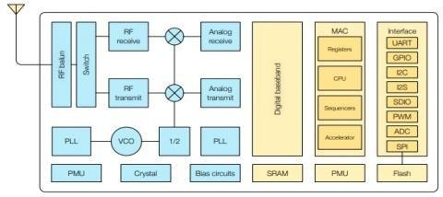

**Figure 4.1.2: Block Diagram**

**History:**

Node MCU was created shortly after the ESP8266 came out. On December 30, 2013, Espressif Systems began production of the ESP8266. Node MCU started on 13 Oct 2014, when Hong committed the first file of node mcu -firmware to Git Hub. Two months later, the project expanded to include an open-hardware platform when developer Huang R committed the gerber file of an ESP8266 board, named devkit v0.9.Later that month, Tuan PM ported MQTT client library from Contiki to the ESP8266 SoC platform and committed to Node MCU project, then Node MCU was able to support the MQTT IOT protocol, using Lua to access the MQTT broker. Another important update was made on 30 Jan 2015, when Devsaurus ported the u8glib to the Node MCU project, enabling Node MCU to easily drive LCD, Screen, OLED, even VGA displays.

**ESP8266 Arduino Core:**

As Arduino.cc began developing new MCU boards based on non-AVR processors like the ARM/SAM MCU and used in the Arduino Due, they needed to modify the ARDUINO NODE so that it would be relatively easy to change the IDE to support alternate tool chains to allow Arduino C/C++ to be compiled for these new processors. They did this with the introduction of the Board Manager and the SAM Core. A "core" is the collection of software components required by the Board Manager and the Arduino IDE to compile an Arduino C/C++ source file for the target MCU's machine language. Some ESP8266 enthusiasts developed an Arduino core for the ESP8266 Wi-Fi SOC, popularly called the "ESP8266 Core for the Arduino IDE ".This has become a leading software development platform for the various ESP8266-based modules and development boards, including Node MCU’s.

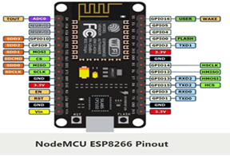

**Figure 4.1.3 NodeMCU ESP8266 pin description**

**Pin description:**

* **A0 PIN:**A 10 KΩ Potentiometer is chosen as the analog input device with its end terminals connected to 3.3V and GND and the Wiper Terminal connected to A0 Pin of Node MCU. The analog voltage is converted to digital values and displayed on the Serial Monitor.
* **RSV RESRVED PINS:**A pin that has been identified as "reserved for future use" and to which neither memory cards nor host systems shall make electrical connections.
* **GPIO9 AND GPIO10:**Also called SD2 and SD3 (digital pins) .These are used while Boot up process. There are certain pins that output a 3.3V signal when the ESP8266 boots. This may be problematic if you have relays or other peripherals connected to those GPIO’s. These GPIO’s output is a HIGH signal on boot.
* **SPI PINS:** SD1, CMD, SD0, CLK. These four pins are available for SPI communication. The Serial Peripheral Interface (SPI) is a synchronous serial communication interface specification used for short-distance communication, primarily in embedded systems.

These SPI’s also support the following general-purpose SPI features:

4 timing modes of the SPI format transfer

Up to 80 MHz and the divided clocks of 80 MHz

Up to 64-Byte FIFO

* **GND:** These are 3 ground pins of NodeMCU-ESP8266

This pin is provided to prevent any accidental damage to equipment and the person handling it case any short circuit or body earth occurs in the equipment.

* **POWER PINS:** They are four pins - Vin and three 3.3V Power supply -3.3 V(3V3):

Vin: External Power Supply

* Regulated 3.3V can be supplied to this pin to power the board.Vin can be used to directly supply the Node MCU/ESP8266 and its peripherals. Power delivered on Vin is regulated through the onboard regulator on the Node MCU module – you can also supply 5V regulated to the VIN pin.3.3V pins are the output of the onboard voltage regulator and can be used to supply power to external components.

**CONTROL PINS:** EN,RST

These pins or button resets the micro controller.

**EN:** The ESP8266 chip is enabled when EN pin is pulled HIGH. When pulled LOW the chipworks at minimum power.

**RST:** pin is used to reset the ESP8266 chip.

**FLASH:** While uploading the code, press the flash button. Keep the flash button pressed while you click once on reset. You may now release the flash button. The ESP8266 will be in flash mode.

Micro-USB:Node MCU can be powered through the USB port.

**UART PINS:** TX,RXUART stands for Universal Asynchronous Receiver/Transmitter. It is a physical circuit in a micro controller, or a stand-alone IC. A UART's main purpose is to transmit and receive serial data.

**DIGITAL PINS:** D0-D8 Pins which are also called as GPIO pins(general purpose input - output) digital pins used to read data from some components (sensors) and write data to other components (actuators). A digital pin can have only 2 states: LOW or HIGH. You can consider them as binary pins.A GPIO is a signal pin on an integrated circuit or board that can be used to perform digital input or output functions. By design it has no predefined purpose and can be used by the hardware or software developer to perform the functions they choose.

**4.2 Buzzer Working & Its Applications**

There are many ways to communicate between the user and a product. One of the best ways is audio communication using a buzzer IC. So during the design process, understanding some technologies with configurations is very helpful. So, this article discusses an overview of an audio signaling device like a beeper or a buzzer and its working with applications.

An audio signaling device like a beeper or buzzer may be electromechanical or piezoelectric or mechanical type. The main function of this is to convert the signal from audio to sound. Generally, it is powered through DC voltage and used in timers, alarm devices, printers, alarms, computers, etc. Based on the various designs, it can generate different sounds like alarm, music, bell & siren.

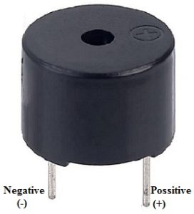

**Figure 4.2.1 BUZZER Pin Configuration**

**Pin description:**

* A0 PIN:A 10 KΩ Potentiometer is chosen as the analog input device with its end terminals connected to 3.3V and GND and the Wiper Terminal connected to A0 Pin of Node MCU. The analog voltage is converted to digital values and displayed on the Serial Monitor.

**Buzzer Pin Configuration**

The pin configuration of the buzzer is shown below. It includes two pins namely positive and negative. The positive terminal of this is represented with the ‘+’ symbol or a longer terminal. This terminal is powered through 6Volts whereas the negative terminal is represented with the ‘-‘symbol or short terminal and it is connected to the GND terminal.

**History**

The history of an electromechanical buzzer and piezoelectric is discussed below.

**Electromechanical**

This buzzer was launched in the year 1831 by an American Scientist namely Joseph Henry but, this was used in doorbells until they were eliminated in 1930 in support of musical bells, which had a smooth tone.

**Piezoelectric**

These buzzers were invented by manufacturers of Japanese & fixed into a broad range of devices during the period of 1970s – 1980s. So, this development primarily came due to cooperative efforts through the manufacturing companies of Japanese. In the year 1951, they recognized the Application Research Committee of Barium Titanate that allows the corporations to be cooperative competitively & bring about numerous piezoelectric creations

**Specifications**

* The specifications of the buzzer include the following.
* Color is black
* The frequency range is 3,300Hz
* Operating Temperature ranges from – 20° C to +60°C
* Operating voltage ranges from 3V to 24V DC
* The sound pressure level is 85dBA or 10cm
* The supply current is below 15mA

**Types of Buzzer**

A buzzer is available in different types which include the following.

* Piezoelectric
* Electromagnetic
* Mechanical
* Electromechanical
* Magnetic

**Working Principle**

The working principle of a buzzer depends on the theory that, once the voltage is given across a piezoelectric material, then a pressure difference is produced. A piezo type includes piezo crystals among two conductors.

Once a potential disparity is given across these crystals, then they thrust one conductor & drag the additional conductor through their internal property. So this continuous action will produce a sharp sound signal.

**Mounting Configurations**

The mounting configurations of buzzers include the following.

* Panel Mount
* Wire Leads
* Screw Terminals
* Through Hole
* Spring Contact
* Surface Mount

**Usage of Buzzer**

A buzzer is an efficient component to include the features of sound in our system or project. It is an extremely small & solid two-pin device thus it can be simply utilized on breadboard or PCB. So in most applications, this component is widely used.

There are two kinds of buzzers commonly available like simple and readymade. Once a simple type is power-driven then it will generate a beep sound continuously. A readymade type looks heavier & generates a Beep. Beep. Beep. This sound is because of the internal oscillating circuit within it.

This buzzer uses a DC power supply that ranges from 4V – 9V. To operate this, a 9V battery is used but it is suggested to utilize a regulated +5V/+6V DC supply. Generally, it is connected through a switching circuit to switch ON/OFF the buzzer at the necessary time interval.

**Choosing of Buzzer**

While choosing a buzzer or speaker, many principles need to consider like the following.

* Size of the product
* Consumption of Current
* Type of terminal
* Frequency Voltage

**Advantages**

The advantages of a buzzer include the following.

* Simply Compatible
* Frequency Response is Good
* Size is small
* Energy Consumption is less
* The Range of Voltage usage is Large
* Sound Pressure is high

**Disadvantages**

The disadvantages of the buzzer include the following.

* Controlling is a little hard
* Generates Annoying Sound
* Training is necessary to know how to repair the condition without just turning off.

**Applications**

The applications of the buzzer include the following.

* Communication Devices
* Electronics used in Automobiles
* Alarm Circuits
* Portable Devices
* Security Systems
* Timers
* Household Appliances
* Sporting Events
* Game Shows

**4.3 MQ2 Gas Sensor Working and Its Applications**

Sensors are the electronic devices used for interaction with the outer environment. There are various types of sensors available that can detect light, noise, smoke, proximity etc… With the advent in technology, these are available as both analog and digital forms. Besides forming a communication with the outer environment, sensors are also a crucial part of safety systems. Fire sensors are used to detect the fire and take appropriate precautions on time. For smooth functioning of control systems and sensitive electronics, humidity sensors are used for maintaining humidity in the unit. One of such sensor used in safety systems to detect harmful gases is MQ2 Gas sensor.

**MQ2 Gas Sensor**

MQ2 gas sensor is an electronic sensor used for sensing the concentration of gases in the air such as LPG, propane, methane, hydrogen, alcohol, smoke and carbon monoxide.

MQ2 gas sensor is also known as chemiresistor. It contains a sensing material whose resistance changes when it comes in contact with the gas. This change in the value of resistance is used for the detection of gas.

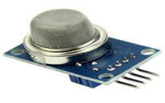

Figure 4.3.1 MQ2 Gas Sensor

MQ2 is a metal oxide semiconductor type gas sensor. Concentrations of gas in the gas is measured using a voltage divider network present in the sensor. This sensor works on 5V DC voltage. It can detect gases in the concentration of range 200 to 10000ppm.

**Working Principle**

This sensor contains a sensing element, mainly aluminium-oxide based ceramic, coated with Tin dioxide, enclosed in a stainless steel mesh. Sensing element has six connecting legs attached to it. Two leads are responsible for heating the sensing element, the other four are used for output signals.

Oxygen gets adsorbed on the surface of sensing material when it is heated in air at high temperature. Then donor electrons present in tin oxide are attracted towards this oxygen, thus preventing the current flow.

When reducing gases are present, these oxygen atoms react with the reducing gases thereby decreasing the surface density of the adsorbed oxygen. Now current can flow through the sensor, which generated analog voltage values.

These voltage values are measured to know the concentration of gas. Voltage values are higher when the concentration of gas is high.

**Applications**

* Detect the presence of gases in the air
* For Air quality monitoring

**4.4 Weight Sensor Working and Its Specifications**

There are several measuring devices in electronics, which can be used for different applications based on their requirements. For measuring weight, there is one sensor namely weight sensor or load cell. This sensor is more prominently used for multiple purposes in weighing systems to measure the weight. A Weight sensor is known for its accuracy and consistency in delivering exact weight values and hence these sensors can be used in designing a weighing system. There is a different range of products available in the market which use sensors like weight measuring devices, used for designing an entire weighing system. This article discusses an overview of the weight sensor and its working with applications.

**Definition:** A load cell or weight sensor is one kind of sensor otherwise a transducer. The working principle of the weight sensor depends on the conversion of a load into an electronic signal. The signal can be a change in voltage; current otherwise frequency based on the load as well as used circuit.

Theoretically, this sensor detects changes within a physical stimulus like force, pressure or weight and produces an output that is comparative to the physical stimulus. So, for a specific stable load otherwise weight size, this sensor provides an output value and that is comparative to the weight’s magnitude. The best example of this sensor module is SEN0160.

The SEN0160 weight sensor module is based on HX711 ADC; it is an accurate 24-bit ADC which is designed for industrial control as well as weighs scale applications to connect straight with a bridge sensor. Evaluated with other integrated circuits, this HX711 includes basic functions and also some features like a quick response, high integration, immunity, etc. This chip reduces the cost of electronic scale as well as improves the reliability and performance.

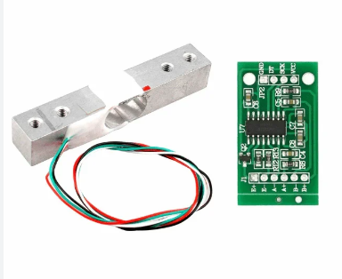

**Fig 4.4.1 wireless-sensor-module**

**Weight Sensor Module Specifications**

This sensor module specification is listed below.

• Capacity is 1kg

• The excitation voltage range is from 5V to 15 V

• O/p sensitivity is 1.0 ± 0.15 mV/V

• Synthetical error is 1 for every thousand cents of complete-scale

• Zero shifts are 0.05 or 0.03

• Zero o/p is ±0.1mV/V

• I/p impedance is 1055±15 Ω

• O/p impedance is 1000±5 Ω

• Overload capacity is 200 %F.S

• Analog output

• 33mm*38mm dimension

**Selecting Load Cell/Weight Sensor**

The selection of a load cell for a specific application can be done by considering the following points.

• Range of measurement

• Based on application

• Capacity requirements

• based on size & specification requirements

• Overload should be best

**4.5 HX711 Specifications**

The specifications of HX711 include the following.

• 24 bit ADC for weight scales

• Two different input channels which are selectable

• Digital control is easy as well as interface is serial

• Selectable o/p data rate is 10SPS otherwise 80SPS

• Instantaneous supply rejection is 50Hz & 60Hz

• The voltage supply is 2.6V to 5.5V

• The current supply is less than 1.6mA

• Working temperature is -40°C to 85°C

• 16- Pin SOP-16 package

**CHAPTER-5**

**SOFTWARE IMPLEMENTATION AND RESULT**

**5.1 CREATING PROJECT IN ARDUINO 1.7.11 VERSION5**

**Arduino Node Installation:** In this we will get know of the process of installation of Arduino IDE and connecting node MCU to Arduino IDE.

**Step 1:** First we must have our Arduino board and a USB cable.

In case we use Arduino NODE MCU, we will need a standard USB cable (A plug to B plug).

**Step 2:** Download Arduino IDE Software.

We can get different versions of Arduino IDE from the Download page on the Arduino Official website. We must select were software, which is compatible with were operating system (Windows, IOS, or Linux). After the file download is complete, unzip the file.

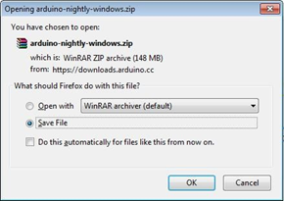

**Fig 5.1.1 Downloading Software**

**Step 3 :**Power up our board.

The Arduino node mcu automatically draw power from either, the USB connection to the computer or an external power supply. If we are using an Arduino Diecimila, we have to make sure that the board is configured to draw power from the USB connection. The power source is selected with a jumper, a small piece of plastic that fits onto two of the three pins between the USB and power jacks.

Check that it is on the two pins closest to the USB port.Connect the Arduino board to were computer using the USB cable. The green power LED (labeled PWR) should glow.

**Step 4 :** Launch Arduino IDE.

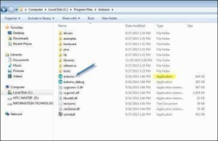

**Fig 5.1.2 Launching Arduino IDE**

After our Arduino IDE software is downloaded, we need to unzip the folder. Inside the folder, we can find the application icon with an infinity label (application.exe). Double- click the icon to start the IDE.

**Step 5 :**Open our first project.Once the software starts, we have two option. Create a new project

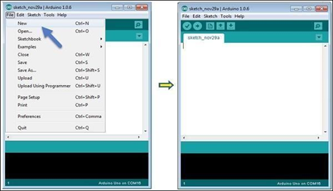

**Fig 5.1.3 Creating process**

Open an existing project example.

To create a new project, select File → New.

To open an existing project example, select File → Example → Basics → Blink

Here, we are selecting just one of the examples with the name Blink. It turns the LED on and off with some time delay. We can select any other example from the list.

**Step 6 :**Select our Arduino board.

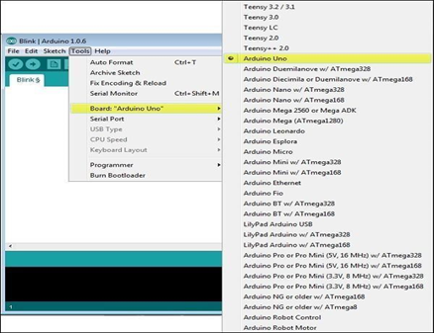

**Fig 5.1.4 Selecting Arduino board**

To avoid any error while uploading program to the board, we must select the correct Ardiuno board name, which matches with the board connected to computer.

Go to Tools → Board and select board.

Here, we have selected Arduino node board according to our tutorial, but we must select the name matching the board that we are using.

**Step 7 :**Select serial port.

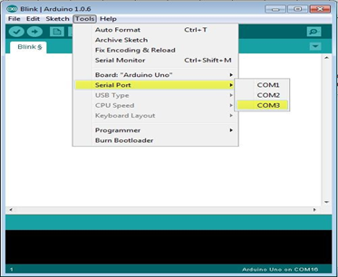

**Fig 5.1.5 Serial port**

Select the serial device of the Arduino board. Go to Tools → Serial Port menu. This is likely to be COM3 or higher (COM1 and COM2 are usually reserved for hardware serial ports). To find out, we can disconnect Arduino board and re-open the menu, the entry that disappears should be of the Arduino board. Reconnect the board and select that serial port.

**Step 8:**Upload the program to board.

Before explaining how we can upload our program to the board, we must demonstrate the function of each symbol appearing in the Arduino IDE toolbar.

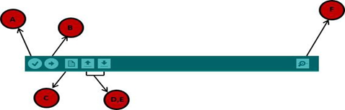

**Fig 5.1.6 Symbols in Arduino Toolbar**

* A − Used to check if there is any compilation error.
* B − Used to upload a program to the Arduino board.
* C − Shortcut used to create a new sketch.
* D − Used to directly open one of the example sketch.
* E − Used to save sketch.
* F − Serial monitor used to receive serial data from the board and send the serial data to the board.

Now, simply click the "Upload" button in the environment. Wait a few seconds; we will see the RX and TX LED’s on the board, flashing. If the upload is successful, the message "Done uploading" will appear in the status bar.

Note − If we have an Arduino Mini, NG, or other board, we need to press the reset button physically on the board, immediately before clicking the upload button on the Arduino Software.

**5.2 Software code:**

#include <ESP8266WiFi.h>

#include <FirebaseArduino.h>

#define FIREBASE_HOST "autobreck-default-rtdb.firebaseio.com"

#define WIFI_SSID "breakiot"

#define WIFI_PASSWORD "breakiot01"

int ir=D5;

int sw=D3;

int mot=D1;

int buz=D0;

int gas=D6;

int k,l,i,m,n,o,d;

int a=0;

int b=0;

void setup()

{

Serial.begin(9600);

pinMode(sw,INPUT_PULLUP);

pinMode(ir,INPUT);

pinMode(gas,INPUT);

pinMode(mot,OUTPUT);

pinMode(buz,OUTPUT);

digitalWrite(mot,HIGH);

digitalWrite(buz,HIGH);

Serial.print("Connecting");

while(WiFi.status() != WL_CONNECTED)

{

Serial.print(".");

delay(500);

}

Serial.println();

Serial.print("connected: ");

Serial.println(WiFi.localIP());

}

void loop()

{

delay(500);

if(Firebase.failed())

{

Serial.print("Firebase error");

Serial.println(Firebase.error());

}

Serial.print("SW1:");

Serial.println(digitalRead(ir));

if(digitalRead(gas)==0)

{

Serial.println("yes gas");

Firebase("BLIND_IOTG/YGAS",i);

i++;

digitalWrite(buz,LOW);

delay(1000);

digitalWrite(buz,HIGH);

}

if(digitalRead(gas)==1)

{

Serial.println("no gas");

Firebase("BLIND_IOTG/NGAS",i);

i++;

digitalWrite(buz,HIGH);

}

if(digitalRead(ir)==0)

{

a=1;

b=1;

digitalWrite(buz,HIGH);

delay(1000);

digitalWrite(mot,LOW);

delay(2000);

digitalWrite(mot,HIGH);

if(digitalRead(sw)==0)

{

digitalWrite(buz,HIGH);

Firebase("BLIND_IOTG/NBUZ",i);

i++;

Serial.println("school no buzer ");

}

Firebase("BLIND_IOTG/YSHL",i);

i++;

}

if(digitalRead(ir)==1)

{

digitalWrite(mot,HIGH);

Firebase("BLIND_IOTG/NSHL",i);

i++;

if(digitalRead(sw)==0)

{

digitalWrite(buz,LOW);

Serial.println("normal buzer high");

delay(2000);

digitalWrite(buz,HIGH);

}

}

}

**CHAPTER** **6**

**ADVANTAGES AND APPLICATIONS**

**6.1 ADVANTAGES:**

• Better monitoring.

• Immediate and accurate values.

• Contact-less.

• Efficient operation management.

• Improved work safety.

• It helps in faster detection of input sensors.

• Real time data access.

**APPLICATIONS:**

• Industrial Field

• Smart city

• Homes

**CHAPTER 6**

**CONCLUSION& FUTURE SCOPE**

**CONCLUSION:**

The developed model saves the time and saves from hazardous gas leakage. It also reduces the manual work of booking gas to distributor. It alerts the gas leakage through buzzer and alert message to respective person and the gas distributor. When compared to others work, it reduces the manual work and it saves the precious time of people.

**FUTURE SCOPE:**

* It sends key information like gas type, pressure, and leak location.
* To predict if any gas leakage occurs, notify the user and close the gas valve automatically

**RESULT**

